**DAY – 9**

**Task 1:**

package com.DAY9;

import org.testng.annotations.Test;

import org.testng.Assert;

import org.testng.annotations.DataProvider;

public class Task1 {

int a,b,c;

@Test(dataProvider = "dp")

public void Add(Integer a, Integer b) {

c = a+b;

System.out.println("Sum = "+c);

Assert.assertEquals(c,15);

}

@Test(dataProvider = "dp")

public void Subract(Integer a, Integer b) {

c = a-b;

System.out.println("Difference = "+c);

Assert.assertEquals(c,7);

}

@Test(dataProvider = "dp")

public void Multipy(Integer a, Integer b) {

c = a*b;

System.out.println("Product = "+c);

Assert.assertEquals(c,44);

}

@Test(dataProvider = "dp")

public void Divide(Integer a, Integer b) {

c = a/b;

System.out.println("Quotient = "+c);

Assert.assertEquals(c,2);

}

@DataProvider

public Object[][] dp() {

return new Object[][] {

new Object[] { 11, 4 },

new Object[] { 13, 5 },

};

}

}

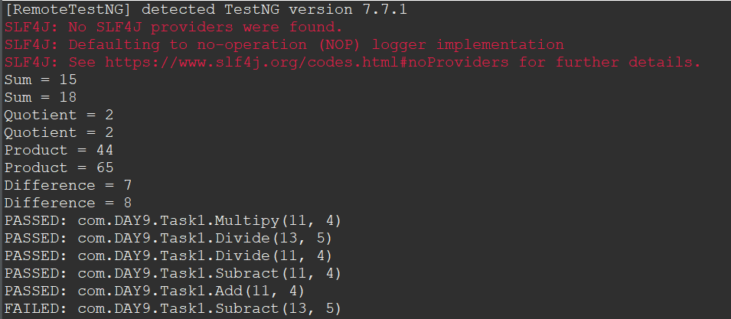

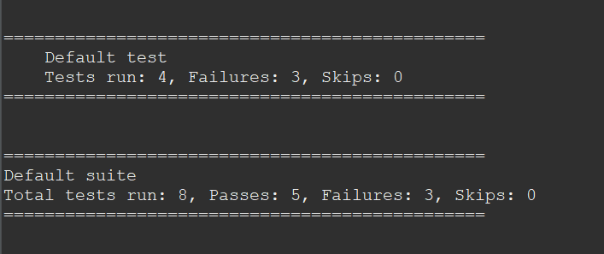

**Task 2&3:**

* **Java Test File**

package com.DAY9;

import org.testng.annotations.Test;

import io.github.bonigarcia.wdm.WebDriverManager;

import java.util.concurrent.TimeUnit;

import org.openqa.selenium.By;

import org.openqa.selenium.WebDriver;

import org.openqa.selenium.WebElement;

import org.openqa.selenium.chrome.ChromeDriver;

import org.openqa.selenium.chrome.ChromeOptions;

import org.testng.Assert;

public class Task2 {

@Test

public void Testcase01() {

WebDriverManager.chromedriver().setup();

ChromeOptions ed= new ChromeOptions();

WebDriver driver=new ChromeDriver(ed);

driver.get("https://www.godaddy.com");

driver.manage().window().maximize();

Assert.assertEquals(driver.getTitle(),"Domain Names, Websites, Hosting & Online Marketing Tools - GoDaddy IN");

Assert.assertEquals(driver.getCurrentUrl(),"https://www.godaddy.com/en-in" );

}

@SuppressWarnings("deprecation")

@Test

public void Testcase02() {

WebDriverManager.chromedriver().setup();

ChromeOptions ed= new ChromeOptions();

WebDriver driver=new ChromeDriver(ed);

driver.get("https://www.godaddy.com");

driver.manage().window().maximize();

driver.manage().timeouts().implicitlyWait(5, TimeUnit.SECONDS);

driver.findElement(By.xpath("//*[@id=\"id-631b049a-e9c0-4d24-8710-c504745206dd\"]/div[2]/div[1]/ul/li[1]/button")).click();

try {

Thread.sleep(2000);

} catch (InterruptedException e) {

// TODO Auto-generated catch block

e.printStackTrace();

}

driver.findElement(By.xpath("//*[@id=\"id-631b049a-e9c0-4d24-8710-c504745206dd\"]/div[2]/div[1]/ul/li[1]/div/div[2]/div[1]/ul/li[2]/a")).click();

}

@SuppressWarnings("deprecation")

@Test

public void Testcase03() {

WebDriverManager.chromedriver().setup();

ChromeOptions ed= new ChromeOptions();

WebDriver driver=new ChromeDriver(ed);

driver.get("https://www.godaddy.com");

driver.manage().window().maximize();

driver.manage().timeouts().implicitlyWait(5, TimeUnit.SECONDS);

driver.findElement(By.xpath("//*[@id=\"id-631b049a-e9c0-4d24-8710-c504745206dd\"]/div[2]/div[1]/ul/li[1]/button")).click();

try {

Thread.sleep(2000);

} catch (InterruptedException e) {

// TODO Auto-generated catch block

e.printStackTrace();

}

driver.findElement(By.xpath("//*[@id=\"id-631b049a-e9c0-4d24-8710-c504745206dd\"]/div[2]/div[1]/ul/li[1]/div/div[2]/div[1]/ul/li[2]/a")).click();

try {

Thread.sleep(4000);

} catch (InterruptedException e) {

// TODO Auto-generated catch block

e.printStackTrace();

}

System.out.println(driver.getTitle());

if(driver.getTitle().equals("GoDaddy Domain Search - Buy and Register Available Domain Names")) {

WebElement search= driver.findElement(By.name("searchText"));

System.out.println(search.isDisplayed());

System.out.println(search.isEnabled());

WebElement buyit=driver.findElement(By.xpath("//*[@id=\"id-1467954b-c5e3-4b0c-9046-9fc94d8ca892\"]/section/div/div/section/div/div[1]/div/div/div[2]/button"));

System.out.println(buyit.isDisplayed());

System.out.println(buyit.isEnabled());

search.sendKeys("monkyhomie");

try {

Thread.sleep(2000);

} catch (InterruptedException e) {

// TODO Auto-generated catch block

e.printStackTrace();

}

buyit.click();

try {

Thread.sleep(6000);

} catch (InterruptedException e) {

// TODO Auto-generated catch block

e.printStackTrace();

}

}

else Assert.assertTrue(false);

}

}

* **XML file**

<?xml version="1.0" encoding="UTF-8"?>

<suite parallel="false" name="Suite">

<test name="Test">

<classes>

<class name="com.DAY9.Task2"/>

</classes>

</test> <!-- Test -->

</suite> <!-- Suite -->

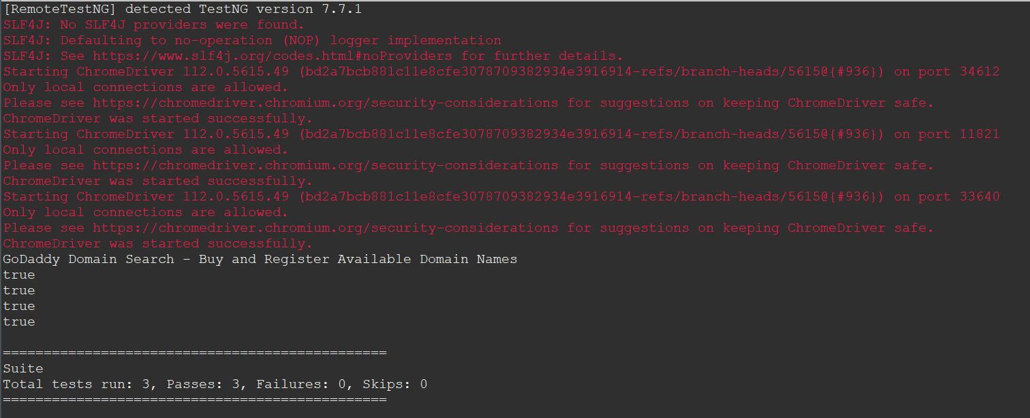

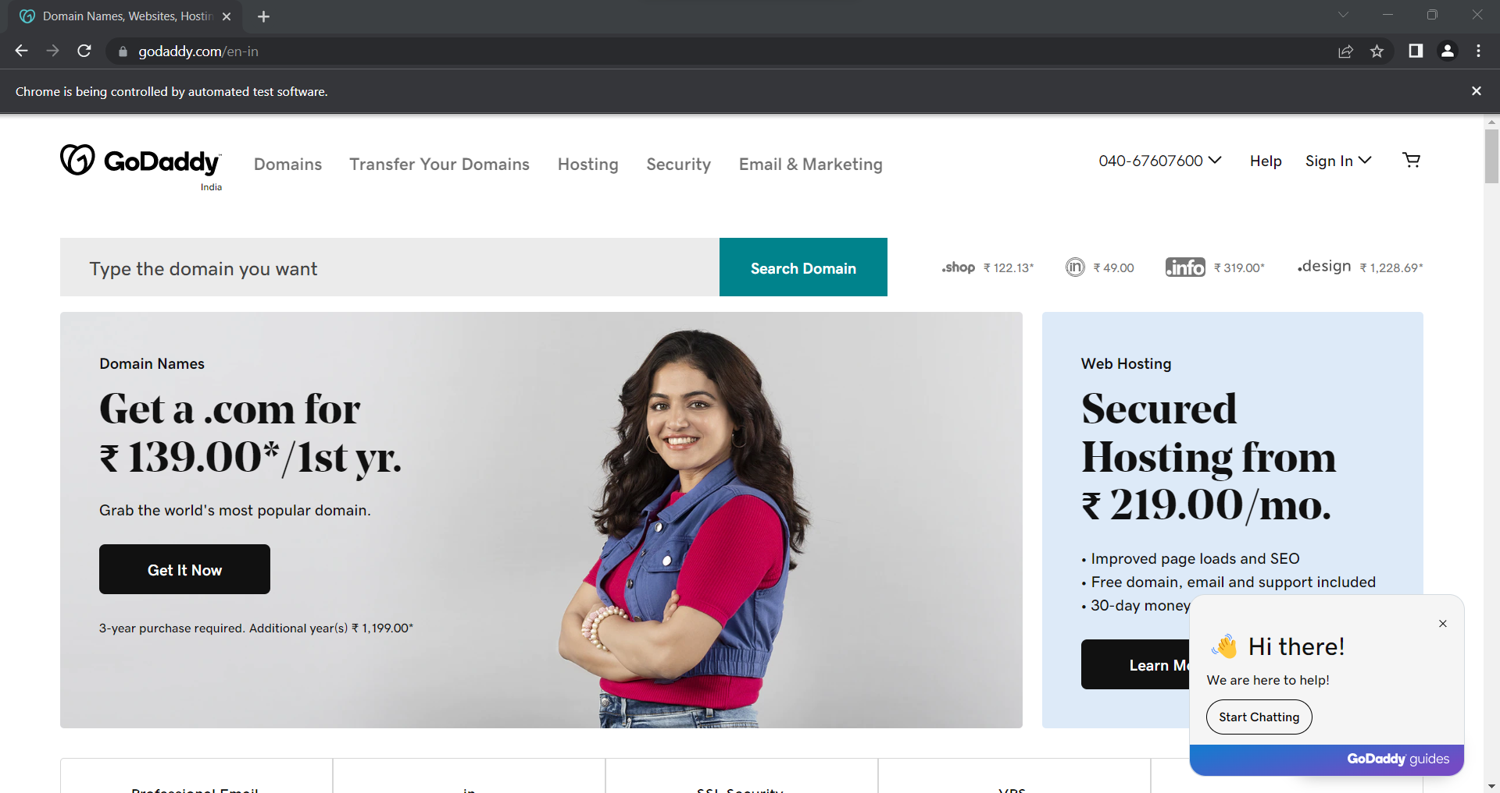

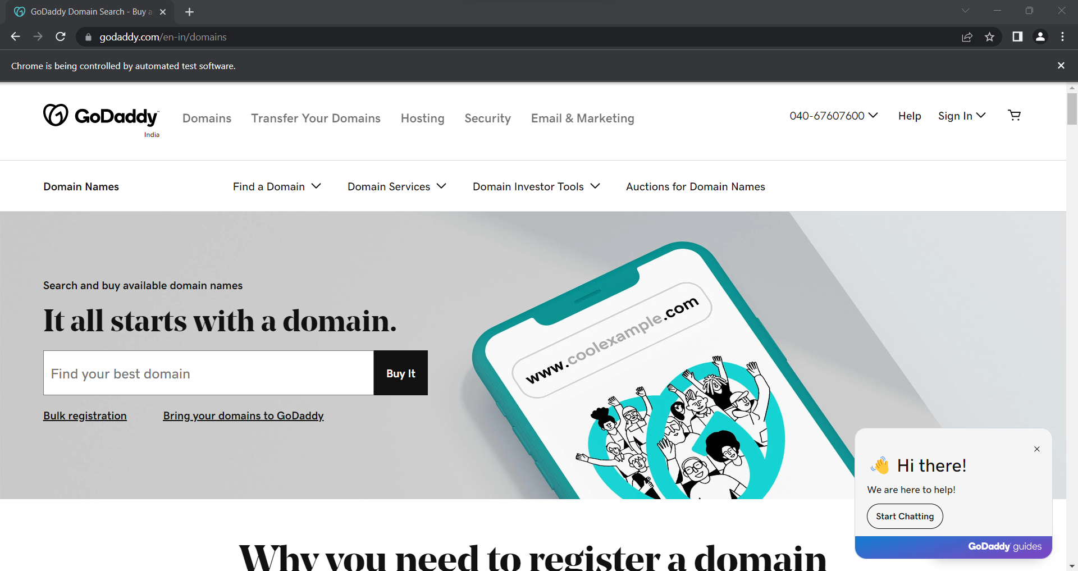

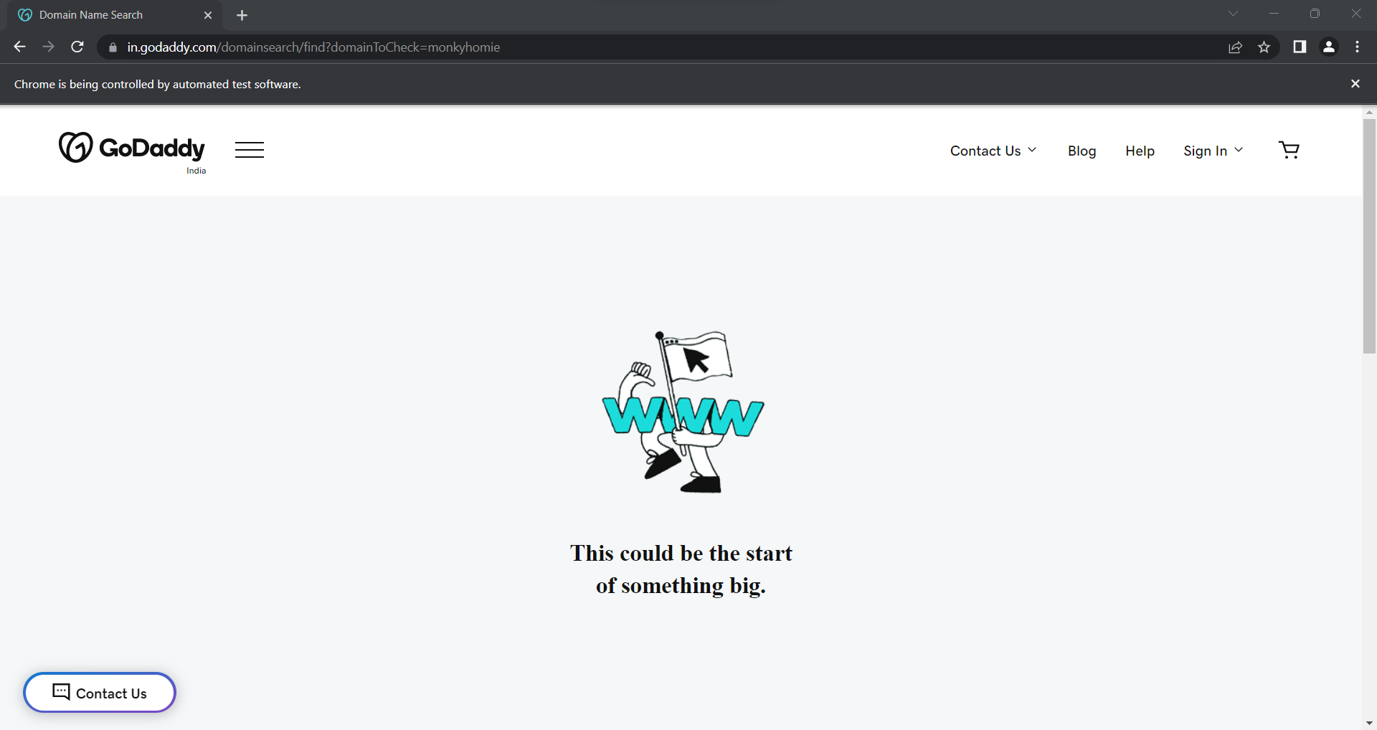

**Task 4:**

* **Java Test file**

package com.DAY9;

import org.openqa.selenium.By;

import org.openqa.selenium.WebDriver;

import org.openqa.selenium.WebElement;

import org.openqa.selenium.chrome.ChromeDriver;

import org.openqa.selenium.chrome.ChromeOptions;

import org.openqa.selenium.edge.EdgeDriver;

import org.openqa.selenium.edge.EdgeOptions;

import org.openqa.selenium.firefox.FirefoxDriver;

import org.openqa.selenium.firefox.FirefoxOptions;

//import org.testng.annotations.AfterMethod;

import org.testng.annotations.BeforeMethod;

import org.testng.annotations.Parameters;

import org.testng.annotations.Test;

import io.github.bonigarcia.wdm.WebDriverManager;

public class Task4 {

WebDriver driver;

@Test

public void f() throws InterruptedException {

Thread.sleep(3000);

WebElement na=driver.findElement(By.xpath("//*[@id=\"app\"]/div[1]/div/div[1]/div/div[2]/div[2]/form/div[1]/div/div[2]/input"));

na.sendKeys("Admin");

Thread.sleep(1000);

WebElement naa=driver.findElement(By.name("password"));

naa.sendKeys("admin123");

Thread.sleep(1000);

WebElement bta=driver.findElement(By.xpath("//*[@id=\"app\"]/div[1]/div/div[1]/div/div[2]/div[2]/form/div[3]/button"));

bta.click();

Thread.sleep(3000);

//String url="https://opensource-demo.orangehrmlive.com/web/index.php/dashboard/index";

//Assert.assertEquals(url,driver.getCurrentUrl());

}

@Parameters({"browser"})

@BeforeMethod

public void setup(String brows) {

if(brows.equals("chrome")) {

WebDriverManager.chromedriver().setup();

ChromeOptions co=new ChromeOptions();

co.addArguments("--remote-allow-origins=*");

driver=new ChromeDriver(co);

driver.get("https://opensource-demo.orangehrmlive.com/web/index.php/auth/login");

driver.manage().window().maximize();

}

else if(brows.equals("edge")) {

WebDriverManager.edgedriver().setup();

EdgeOptions co=new EdgeOptions();

co.addArguments("--remote-allow-origins=*");

driver=new EdgeDriver(co);

driver.get("https://opensource-demo.orangehrmlive.com/web/index.php/auth/login");

driver.manage().window().maximize();

}

else if(brows.equals("firefox")) {

WebDriverManager.firefoxdriver().setup();

FirefoxOptions co=new FirefoxOptions();

co.addArguments("--remote-allow-origins=*");

driver=new FirefoxDriver(co);

driver.get("https://opensource-demo.orangehrmlive.com/web/index.php/auth/login");

driver.manage().window().maximize();

}

}

}

* **XML file**

<?xml version="1.0" encoding="UTF-8"?>

<suite parallel="false" name="Suite">

<test name="Test">

<parameter name="browser" value="edge"></parameter>

<classes>

<class name="com.DAY9.Task4"/>

</classes>

</test> <!-- Test -->

</suite> <!-- Suite -->

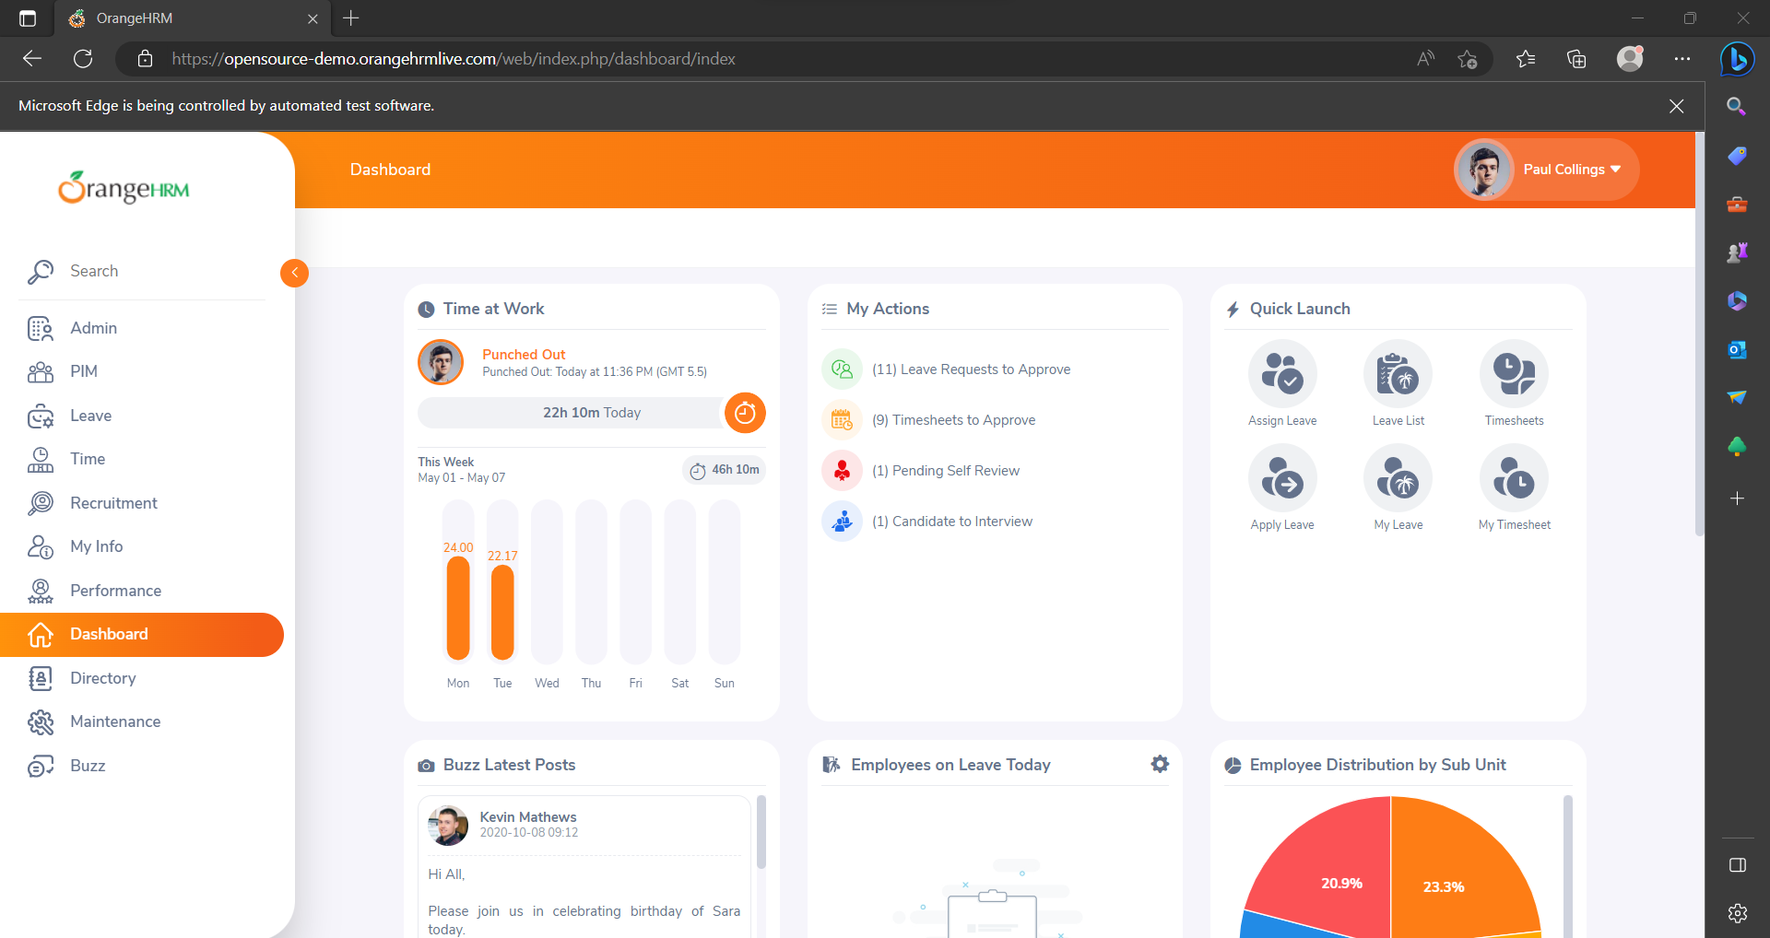

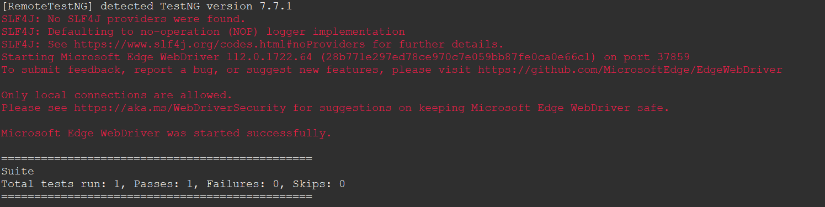

**Task 5:**

* **Java Test file**

package com.DAY9;

import org.openqa.selenium.By;

import org.openqa.selenium.WebDriver;

import org.openqa.selenium.WebElement;

import org.openqa.selenium.chrome.ChromeDriver;

import org.openqa.selenium.chrome.ChromeOptions;

import org.openqa.selenium.edge.EdgeDriver;

import org.openqa.selenium.edge.EdgeOptions;

import org.testng.Assert;

import org.testng.annotations.AfterMethod;

import org.testng.annotations.BeforeMethod;

import org.testng.annotations.Parameters;

import org.testng.annotations.Test;

import io.github.bonigarcia.wdm.WebDriverManager;

public class Task5 {

WebDriver driver;

@Test

public void f() throws InterruptedException {

Thread.sleep(3000);

WebElement na=driver.findElement(By.xpath("//*[@id=\"app\"]/div[1]/div/div[1]/div/div[2]/div[2]/form/div[1]/div/div[2]/input"));

na.sendKeys("Admin");

Thread.sleep(1000);

WebElement naa=driver.findElement(By.name("password"));

naa.sendKeys("admin123");

Thread.sleep(1000);

WebElement bta=driver.findElement(By.xpath("//*[@id=\"app\"]/div[1]/div/div[1]/div/div[2]/div[2]/form/div[3]/button"));

bta.click();

Thread.sleep(3000);

String url="https://opensource-demo.orangehrmlive.com/web/index.php/dashboard/index";

Assert.assertEquals(url,driver.getCurrentUrl());

}

@BeforeMethod

public void setup() {

WebDriverManager.chromedriver().setup();

ChromeOptions co=new ChromeOptions();

co.addArguments("--remote-allow-origins=*");

driver=new ChromeDriver(co);

driver.get("https://opensource-demo.orangehrmlive.com/web/index.php/auth/login");

driver.manage().window().maximize();

}

@AfterMethod

public void teardown() throws InterruptedException {

Thread.sleep(4000);

driver.close();

}

}

* **Listener file**

package com.DAY9;

import org.testng.ITestContext;

import org.testng.ITestListener;

import org.testng.ITestResult;

public class Task5Listener implements ITestListener{

public void onTestStart(ITestResult result) {

System.out.println("onTestStart"+result.getName());

}

public void onTestSuccess(ITestResult result) {

System.out.println("onTestSuccess"+result.getName());

}

public void onTestFailure(ITestResult result) {

System.out.println("onTestFailure"+result.getName());

}

public void onTestSkipped(ITestResult result) {

System.out.println("onTestSkipped"+result.getName());

}

public void onTestFailedButWithinSuccessPercentage(ITestResult result) {

System.out.println("onTestFailedButWithinSuccessPercentage"+result.getName());

}

public void onTestFailedWithTimeout(ITestResult result) {

System.out.println("onTestFailedWithTimeout"+result.getName());

}

public void onStart(ITestContext context) {

System.out.println("onStart"+context.getName());

}

public void onFinish(ITestContext context) {

System.out.println("onFinish"+context.getName());

}

}

* **XML file**

<?xml version="1.0" encoding="UTF-8"?>

<suite parallel="false" name="Suite">

<test name="Test">

<listeners>

<listener class-name="com.DAY9.Task5Listener">

</listener>

</listeners>

<classes>

<class name="com.DAY9.Task5"/>

</classes>

</test> <!-- Test -->

</suite> <!-- Suite -->

